#######################Checkpoint 5.1########################

4. It would be preferable to consider an attribute an entity when you want to store information about that attribute because in order to store information about something, it has to be an entity with attributes.

5. Yes, it makes sense to have an entity with only one attribute, but in some cases, they could be combined to form a composite attribute.

#######################Checkpoint 5.2########################

1. The relationship between entities can change over time. There may be different types of relationships that can form, dissolve, and evolve between entities based on the client’s needs.
2. Attributes are not permanent. For example, phone numbers and addresses are subject to change.
3. A “binary relationship” is a relationship between two entities.

#######################Exercise 5.2##########################

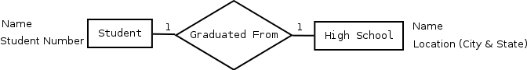

#######################Exercise 5.4##########################

A **PLANE** is flown by a **PILOT.**